



APRIL EXAMKNATMON

NATIONAL CERTIFICATE

# STRENGTH OF MATERIALS AND STRUCTURES N6

(8060076)

3 April 2013 (X-Paper)



REQUIREMENTS: Hot rolled structural steel sections BOE 8/2

Calculators may be used.

This question paper consists of 5 pages and a 3-page information sheet.

DEPARTMENT OF HIGHER EDUCATION AND TRAINING

REPUBLIC OF SOUTH AFRICA

NATIONAL CERTIFICATE

STRENGTH OF MATERIALS AND STRUCTURES N6

TIME: 3 HOURS

MARKS: 100

INSTRUCTIONS AND INFORMATION Answer ALL the questions.

1. Read ALL the questions carefully.
2. Number the answers according to the numbering system used in this question paper.
3. Draw a line after each part of a question.
4. Show ALL steps of calculations: formulae, values and answers.
5. Write neatly and legibly.

1

A hollow shaft turns at 200 r/min and carries a flywheel with a weight of 5 kN. The flywheel is placed 300 mm from the one bearing on the shaft with a length of 800 mm. Consider the shaft as simply supported. The allowable tensile stress and shear stress in the shaft must not exceed 85 MPa and 65 MPa respectively.

Calculate the power that can be transmitted by the shaft if the maximum torque is 13 per cent more than the mean torque. The outside diameter of the shaft is 80 mm and the inside diameter is 70 mm.

## QUESTION 2

A column is subjected to a load of I F newton which causes a stress of 85 MPa in the cross section of the column. The column is supported by a square foundation with a total area of 9 square metres and a weight of 5 kN. The bearing capacity of the soil is 220 kPa.

Calculate the following:

|  |  |
| --- | --- |
| 2.1 The magnitude of the load 'F'  2.2 A suitable parallel flange H-section which can be used as the column  2.3 The actual stress in the selected HI-section  QUESTION 3  A reinforced concrete beam of rectangular cross section carries a uniformly distributed load, including the weight of the beam of 8 kN/m over its full length of 6 m. A point load of 300 kN is placed 2 metres from the one end of the beam which is simply supported. The width of the beam is equal to 0,5 times the total depth of the beam and the centre of the reinforcement is 0, 15 times the total depth from the bottom of the beam. The allowable stresses for the steel and the concrete are 140 MPa and 8 MPa respectively and m = 15.  Calculate the following:  3.1 The maximum moment of resistance for the beam if it occurs at the point load  3.2 The depth and breadth for the beam | (3)  (3)  (2)  (6)  (9) |

[15]

4

A parallel flange I-section, 203 by 133 by 25,3 kg/m is used as a tie and subjected to a tensile force of 200 kN. This load is applied on the centroid of the cross section of the I-section. A point load of 100 kN is applied at mid-span of the tie with a length of 3 m.

Calculate the following:

|  |  |
| --- | --- |
| 4.1 The maximum tensile stress in the tie  4.2 The position of the neutral axis | (6)  (2) |

## QUESTION 5

A sirnply supported beam with a length I L' metres carries a uniformly distributed load of 30 kN/m excluding its weight. A 305 by 305 by 283 kg/m H-section is used as the beam. The deflection of the beam must not exceed 1/250 of its length and the stress is limited to 120 MPa. 200 GPa.

Calculate the following:

|  |  |
| --- | --- |
| 5.1 The allowable length of the beam so as not to exceed any limits  5.2 The maximum slope of the beam as a result of bending | (12)  (3)  [15] |

## QUESTION 6

A hydraulic cylinder with a ram of 150 mm diameter lifts a load of 1 MN. The maximum allowable safe tensile stress in the cylinder wall of the cylinder is 120 MPa and the inside diameter of the cylinder is the same as the diameter of the ram. Use Lames equations and calculate the following:

6.1 The outside diameter of the cylinder (8)

6.2 The longitudinal stress in the cylinder wall (2)

6.3 The strain at the outer diameter of the cylinder wall if Young i s modulus for the cylinder material is 200 GPa. (1 )

7

Water with a density of 1 100 kg/m 3 is retained by a wall with a trapezium crosssectional shape. The width of the wall at the top is 600 mm and the width of the base is 1 600 mm. The vertical side that retains the water is 3 m high. The density of the wall material is 2 400 kg/m3 .

Calculate the following:

7.1 The position of the resultant ground reaction if the depth of the water is 3 m 

|  |  |
| --- | --- |
| 7.2 The depth of the water if the resultant ground reaction is 300 mm from the middle of the base towards the toe  QUESTION 8  One end of a rope is attached to a tower and part of the rope is lying flat on the ground. This forms an angle of 60 0 with the top of the tower. The maximum tension in the rope is 20 kN and the weight of the cable is 130 N/m.  Calculate the following:  8.1 The length of the rope lying flat on the ground if the total length of the rope is 160 m  8.2 The height of the tower  8.3 The minimum tension in the rope  TOTAL: | (7)  (6)  (3)  (1 )  100 |



### STRENGTH OF MATERIALS AND STRUCTURES

#### INFORMATION SHEET

Any applicable equation or formula may be used.





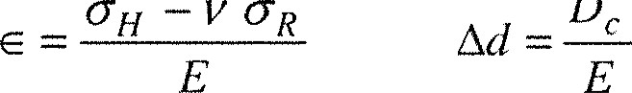[CHI —OH21

Ad = D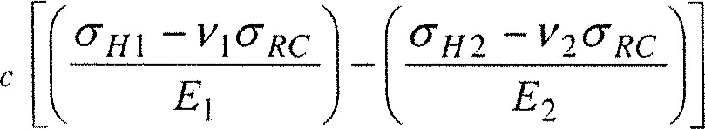

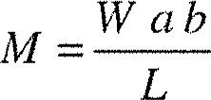

IVI=WL

2 El 3 El

#### 6 El

 16 El 48 E I 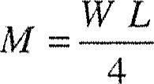

 24 E' 1 384 E 1 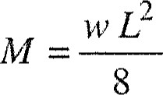

Please turn over

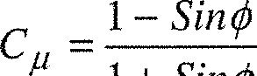

I + Sill"

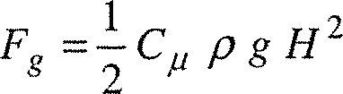



 (x = distance from toe)

EVV-M F.O.S.

F.O.S.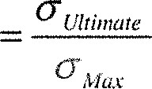

F.O.S— EF — Forces

01 1 — Sin"



p g 1+ Sin"

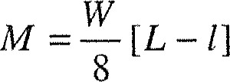

##### nt(d — n)

n

— cc b n la 

m As (d — n) = Al n —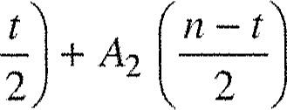

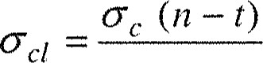

n

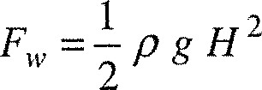

### F cu pH

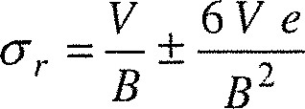

[L - 11 2

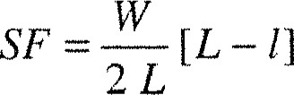

= m As

n

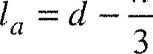



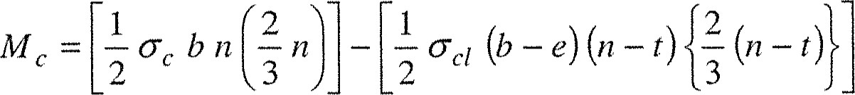



Please turn over

I l = yo Tan 0 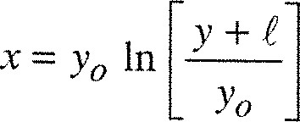

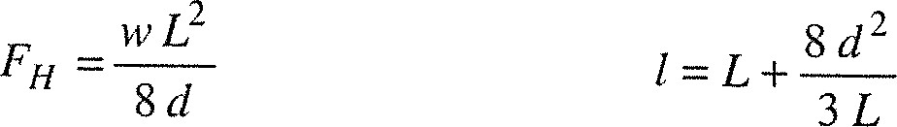

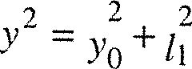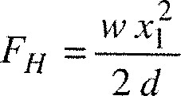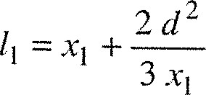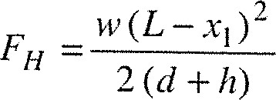 cose =

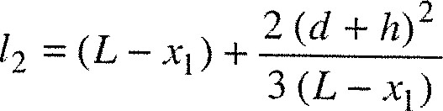

 = VVx- +

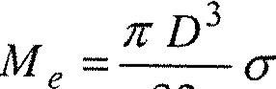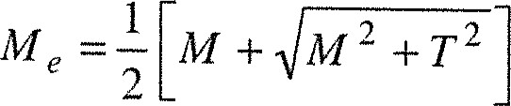 32 n



16 Ina,x

#### Replace 3 with D 4 —d 4